**Lcd interface- programmable digital data display system.**

**Circuit Diagram:**

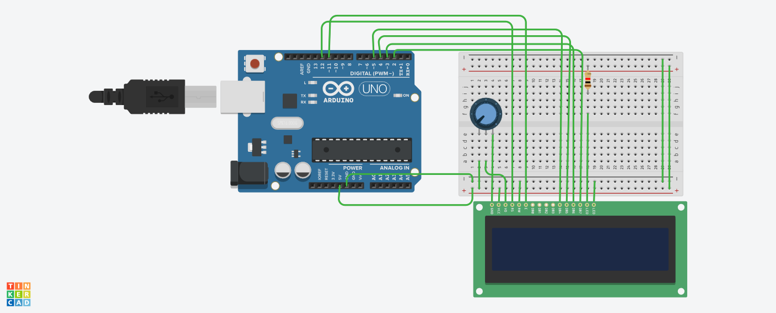

**Theory:**

Concepts Used:

1. Using of LCD.
2. Coding Arduino.

**Learning & Observations**:

Learned the use of LCD.

We can make many useful devices using LCD.

**Problems & Troubleshooting**

Unknowingly the connections of lcd was made wrong.

Understood the mistake and connected properly.

**Precautions**

1. Check the LED,LCD and Arduino are working properly.
2. Declare pins used .
3. Make the connections of lcd correctly.

**Learning Outcomes**

Learned usage and coding of LCD and it was really fun .Things I learned will be very useful.